**Blood Donation Start look:**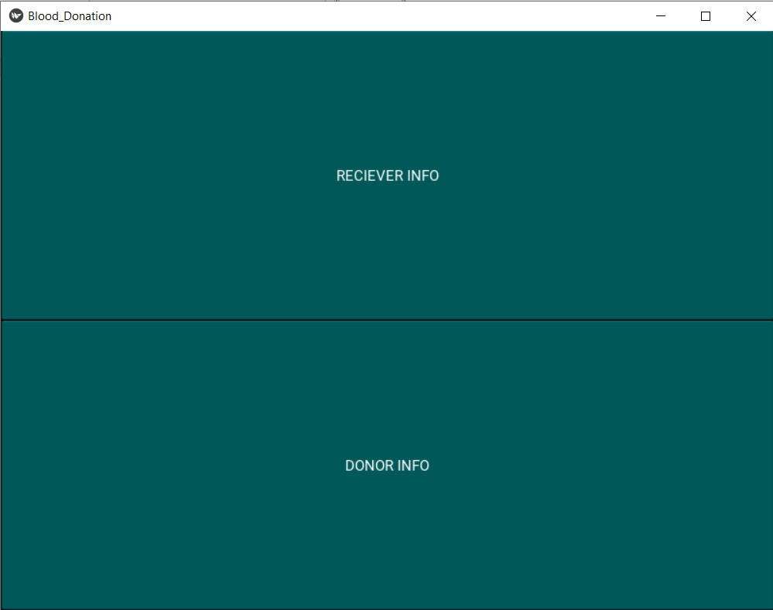

**RECIVER TAB:**

**Confirmation that the user have received blood:**

**THANK YOU, TAB:**

**Taking Blood Donation information:**

